Tutorial in Analysis Modeling : OnLine Shopping
Topics
- Online Shopping – Tutorial Statement
- Use Case Modeling
- Activity Modeling
- Class Modeling
- Interaction Modeling
- Statechart Modeling

OnLine Shopping – Order Processing
- Buying computers via Internet
- The computers are classified into servers, desktops and portables
- The customer can select a standard configuration or can build a desired configuration online
- To place an order, the customer must fill out the shipment and payment information (payment methods are credit cards and checks )
- Once the order has been entered, the system sends a configuration e-mail message to the customer with details of the order
- The customer can check online at any time the order status
- The back end order processing consists of steps needed to
  - verify the customer’s credentials and payment method,
  - to request the ordered configuration from the warehouse,
  - to print an invoice, and request, and
  - to request the warehouse to ship the computer to the customer
- The ordered configuration is shipped to the customer together with the invoice

Use case modeling
- System behavior is what a system does when responding to external events
- Use case - outwardly visible and testable system behavior
- Actor - whoever or whatever (person, machine, etc.) that interacts with a use case
- Actor receives a useful result
- Use case represents a complete unit of functionality of value to an actor
- There may be some use cases that do not directly interact with actors
- In many instances, a function requirement maps directly to a use case
- Use Case Diagram is a visual representation of actors and use cases together with any additional definitions and specifications

Extended requirements (scenario)
- The customer uses the manufacturer’s online shopping web page to view the standard configuration of the chosen servers, desktops or portable computer. The price is also shown.
- The customer chooses to view the details of the configuration, perhaps with the intention of buying it as is or to build a more suitable configuration. The price for each configuration can be computed at the customer’s request.
- The customer may choose to order the computer online or may request that the salesperson contact him/her to explain order details, negotiate the price, etc before the order is actually placed.
- To place the order, the customer must fill out an online form with shipment and invoice address, and with payment details (credit card or check).
- After the customer’s order has been entered into the system, the salesperson sends an electronic request to the warehouse with details of the ordered configuration.
- The details of the transaction, including an order number and customer account number, are e-mailed to the customer, so that the customer can check the status of the order online.
- The warehouse obtains the invoice from the salesperson and ships the computer to the customer.

Actors
- Actors and use cases are determined from the requirement:
After customer’s order has been entered into the system, the salesperson sends an electronic request to the warehouse with details of the ordered configuration

Customer
Salesperson
Warehouse

Use cases
- The customer uses the manufacturer’s online shopping Web page to view the standard configuration of the chosen server, desktop or portable computer
- The customer chooses to view the details of the configuration, perhaps with the intention to buy it as is or to build a more suitable configuration
Display Standard
Computer Configuration
Build Computer
Configuration
Order Configured
Computer
Verify and Accept
Customer Payment
Print Invoice
Update
Order Status
Request
Salesperson Contact
Inform Warehouse
about Order

Use Case Diagram

Display Standard
Computer Configuration
Build Computer
Configuration
Verify and Accept
Customer Payment
Customer
Order Configured
Computer
Request
Salesperson Contact
<<extend>>
Inform Warehouse
Warehouse
Print Invoice
Salesperson
Update
Order Status
The <<extend>> relationship - the use case Order Configured Computer can be extended by Customer with the use case Request Salesperson Contact

Documenting use cases
- Brief Description
- Actors involved
- Preconditions necessary for the use case to start
- Detailed Description of flow of events that includes:
  - Main Flow of events, that can be broken down to show:
    - Subflows of events (subflows can be further divided into smaller subflows to improve document readability)
  - Alternative Flows to define exceptional situations
- Postconditions that define the state of the system after the use case ends

Narrative use case specification

Use Case | Order Configured Computer
Brief Description | This use case allows a Customer to enter a purchase order. …
Actors | Customer
Preconditions | The page displays the details of a configured computer together with its price. …
Main Flow | The system assigns a unique order number and a customer account number to the purchase order and it stores the order information in the database. …
Alternative Flows | The Customer activates the Purchase function before providing all mandatory information. …
Postconditions | If the use case was successful, the purchase order is recorded in the system’s database.

Activity Modeling
- Activity model
  - Can graphically represent the flow of events of a use case
  - Can be used to understand a business process at a high-level of abstraction before any use cases are produced
- Shows the steps of a computation
  - Each step is a state of doing something
  - Execution steps are called activity states
  - Depicts which steps are executed in sequence and which can be executed concurrently
  - Transition – the flow of control from one activity state to the next
- Use case descriptions are (usually) written from an outside actor’s perspective
- Activity models take an inside system’s viewpoint

Activities
- Activity states can be established from the use case document
- Activities should be named from the system’s perspective, not the actor’s viewpoint
- Activity takes time to complete
- Action is so quick that – on our time scale – it is considered to take no time at all
- UML uses the same same graphical symbol for activity state and action state – rounded rectangle

Activities in main and alternative flows

N

Use case statement

Activity state

1

The use case begins when the Customer decides to order the configured computer by choosing the Continue (or similarly named) function when the order details are displayed on the screen.
Display Current Configuration; Get Order Request

2

The system requests that the Customer enter the purchase details including: name of the salesperson (if known), shipment details (customer’s name and address), invoice details (if different from shipment details), a payment method (credit card or check) and any comments.
Display Purchase Form
3

The Customer chooses the Purchase (or similarly named) function to send the order to the manufacturer.
Get Purchase Details

4

The system assigns a unique order number and a customer account number to the purchase order and it stores the order information in the database.
Store Order

5

The system e-mails to the Customer the order number and a customer account number together with all order details, as the confirmation of the order’s acceptance.
Email Order Details

6

The Customer activates the Purchase function before providing all mandatory information. The system displays an error message and it requests that the missing information be supplied.
Get Purchase Details; Display Purchase Form

7

The Customer chooses the Reset (or similarly named) function to revert to an empty purchase form. The system allows the Customer to enter the information again.
Display Purchase Form

Activities
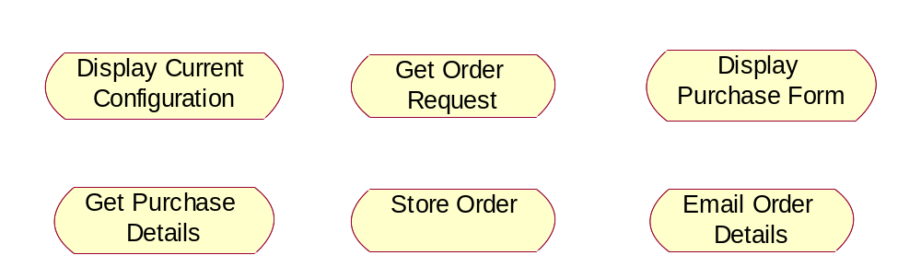

- The system assigns a unique order number and a customer account number to the purchase order and it stores the order information in the database.

Activity Diagram
- Activity Diagram shows transitions between activities
- A solid filled circle represents the initial state
- The final state is shown using so called bull’s eye symbol
- Transitions can branch and merge (diamond) – alternative computation threads
- Transitions can fork and re-join (bar line) –concurrent (parallel) computation threads
- Activity diagram without concurrent processes resembles a conventional flowchart

Activity Diagram

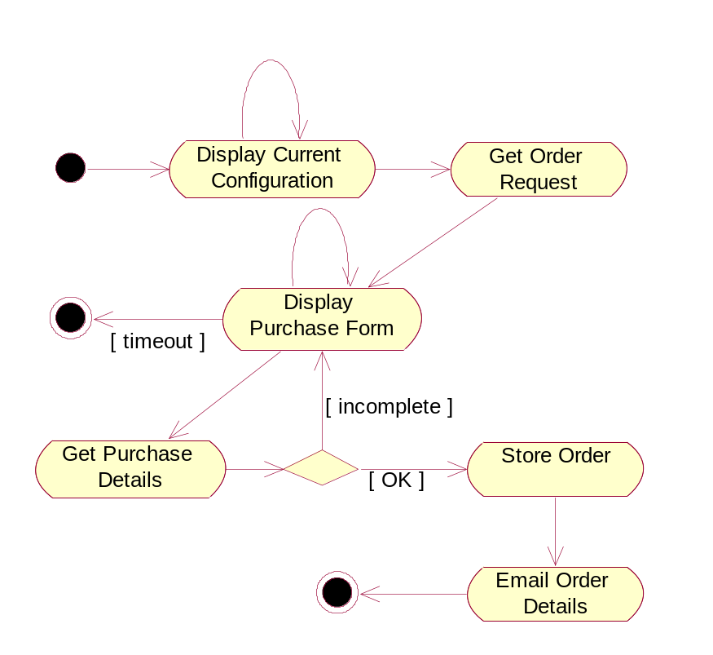
Multiple exit transitions (branch condition that is internal to activity state)
Explicit branch condition (that appears on exit from activity state)

Class Modeling
- Captures system state – the function of the system's information content at a point in time
- Class modeling elements:
  - classes themselves
  - attributes and operations of classes
  - Relationships – associations, aggregation and composition, generalization
- Class Diagram – combined visual representation for class modeling elements
- Class modeling and use case modeling are typically conducted in parallel

Classes
- So far, we have used classes to define "business objects"
  - Called entity classes (model classes)
  - Represent persistent database objects
- Other classes
  - Classes that define GUI objects (such as screen forms) – boundary classes (view classes)
  - classes that control the program's logic – control classes
- Boundary and control classes may or may not be addressed in requirements analysis – may be delayed until the system design phase

- Is this a class?
  - Is the concept a container for data?
  - Does it have separate attributes that will take on different values?
  - Would it have many instance objects?
  - Is it in the scope of the application domain?
- The warehouse obtains the invoice from the salesperson and ships the computer to the customer

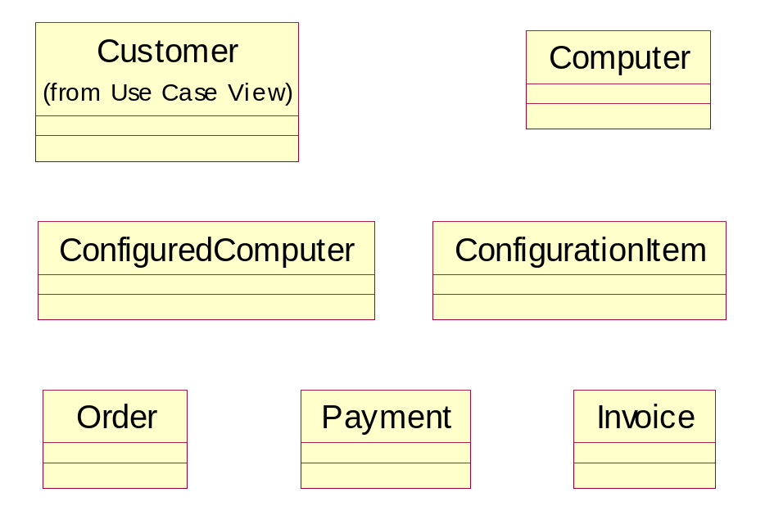
Is Salesperson a class or an attribute of Order and Invoice?
Do we need Shipment class? Is it in the scope?

Attributes
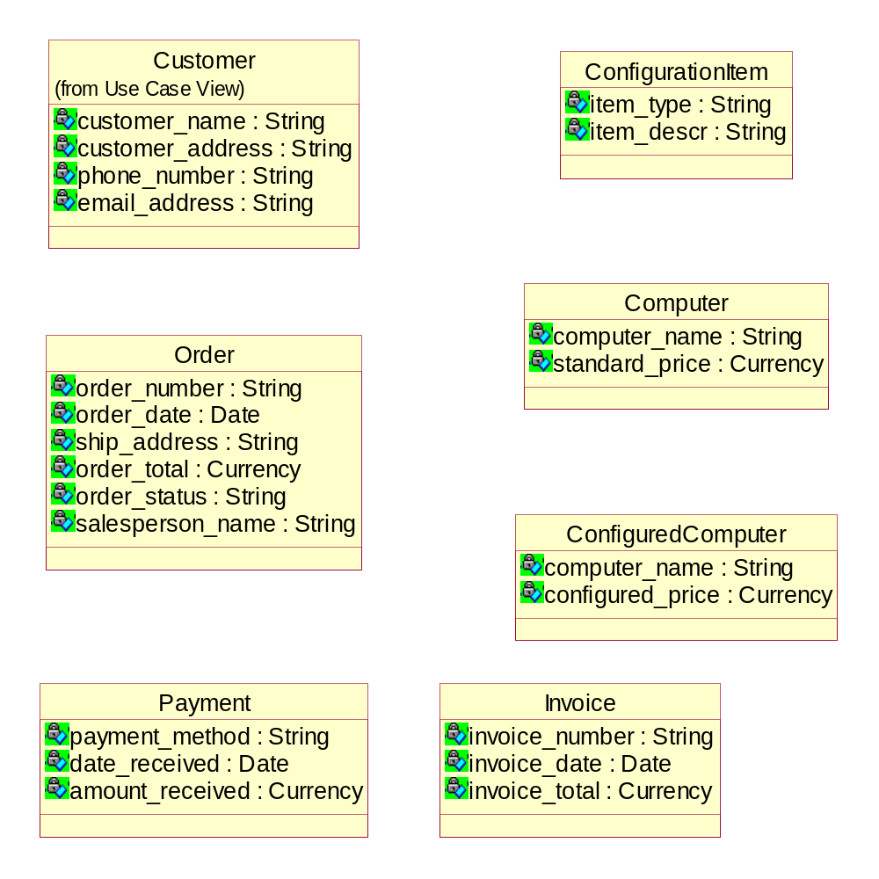

Associations
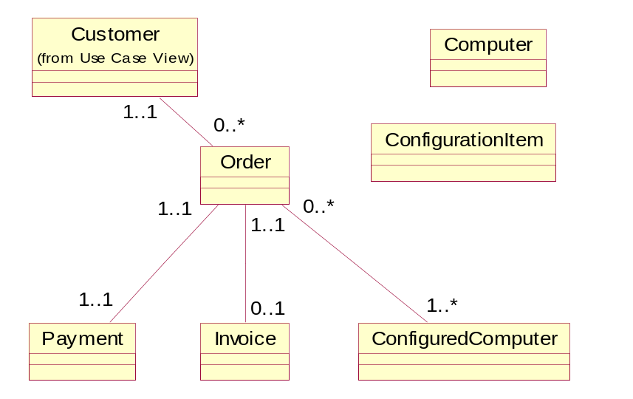

Aggregations
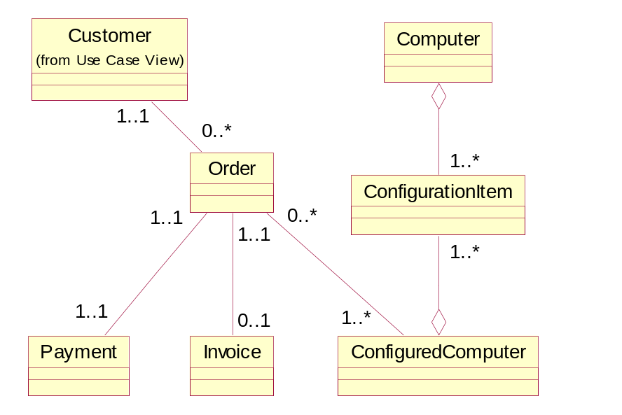
Generalizations
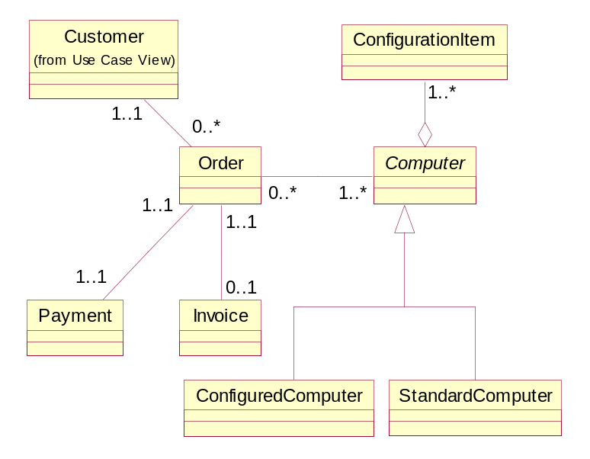

Class Diagram
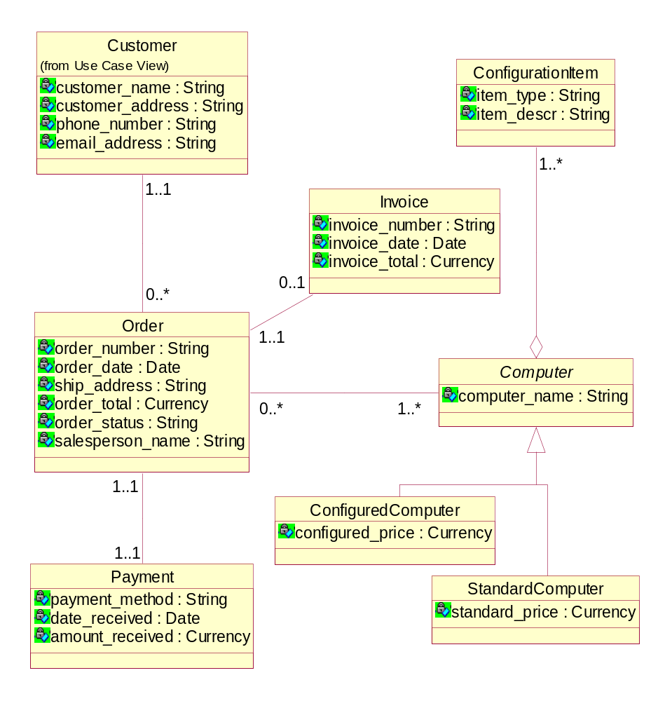
Interaction modeling
- Captures interactions between objects needed to execute a use case
- Shows the sequencing of events (messages) between collaborating objects
- Used in more advanced stages of requirements analysis, when a basic class model is known, so that the references to objects are backed by the class model
- Two kinds of interaction diagrams
  - Sequence Diagram – concentrate on time sequences
  - Collaboration Diagram – emphasize object relationships
- Prevailing IS development practice – Sequence Diagrams in requirements analysis and Collaboration Diagrams in system design

Interactions
- Interaction – set of messages in some behavior that are exchanged between objects across links
- Sequence Diagram
  - Objects - horizontal dimension
  - Message sequence - top to bottom on vertical dimension
  - Each vertical line - the object's lifeline
  - Arrow - message from a calling object (sender) to an operation (method) in the called object (target)
    - Actual argument can be
      - input argument (from the sender to the target)
      - output argument (from the target back to the sender).
- crs_ref.getCourseName(out crs_name)
  - Showing the return of control from the target to the sender is not necessary
  - Iteration marker – an asterisk in front of the message label – indicates iterating over a collection

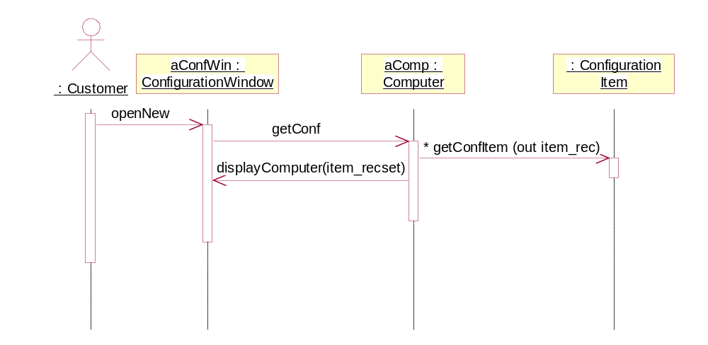
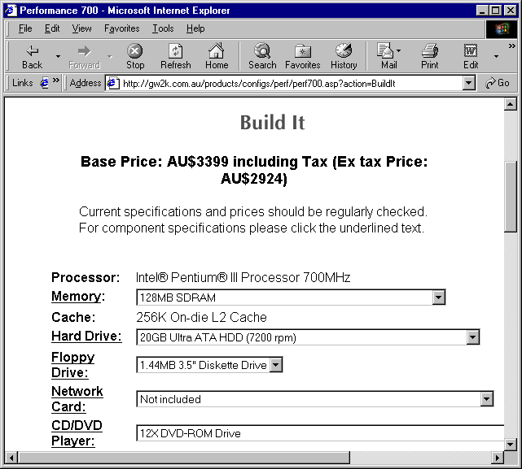

Operations
- Examining the interactions can lead to the discovery of operations
  - Each message invokes an operation in the called object
  - The operation has the same name as the message
- Similarly, the presence of a message in a Sequence Diagram stipulates the need for an association in the Class Diagram
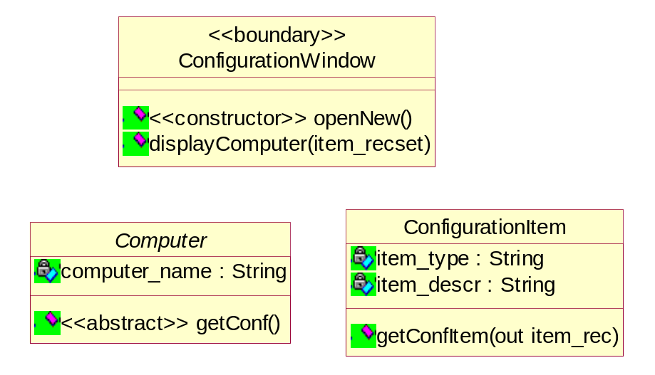
Sequence Diagram
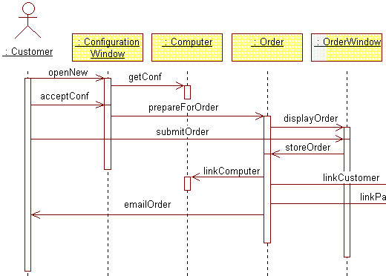
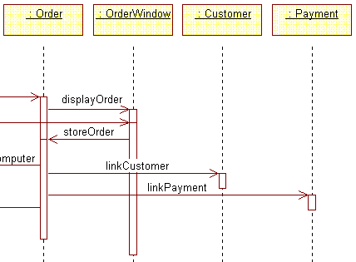

Statechart modeling

- Captures dynamic changes of class states – the life history of the class
- These dynamic changes describe typically the behavior of an object across several use cases
- State of an object – designated by the current values of the object's attributes
- Statechart Diagram – a bipartite graph of
  - states (rounded rectangles) and
  - transitions (arrows) caused by events
- The concepts of states and events are the same concepts that we know from Activity Diagrams – the difference is that “the states of the activity graph represent the states of executing the computation, not the states of an ordinary object”

States and transitions
- Objects change values of their attributes but not all such changes cause state transitions
- We construct state models for classes that have interesting state changes, not any state changes
- Statechart Diagram is a model of business rules
  - Business rules are invariable over some periods of time
  - They are relatively independent of particular use cases

Unpaid
Partly Paid
Fully Paid
partial payment
final payment
final payment
Statechart Diagram
- Normally attached to a class, but can be attached to other modeling concepts, e.g. a use case
- When attached to a class, the diagram determines how objects of that class react to events
  - Determines – for each object state – what action the object will perform when it receives an event
  - The same object may perform a different action for the same event depending on the object’s state
  - The action’s execution will typically cause a state change
- The complete description of a transition consists of three parts
event (parameters) [guard] / action

- Action – short atomic computation that executes when the transition fires
  - can also be associated with a state
- Activity – longer computation associated with a state

